Test Case: tc006_SPX_Dev5_Crear_Requisicion_Spot_Tipo_Cobro_Proyect_Urgent
Step 1 - Enter username and password and click to button Enter: Credentials Entered
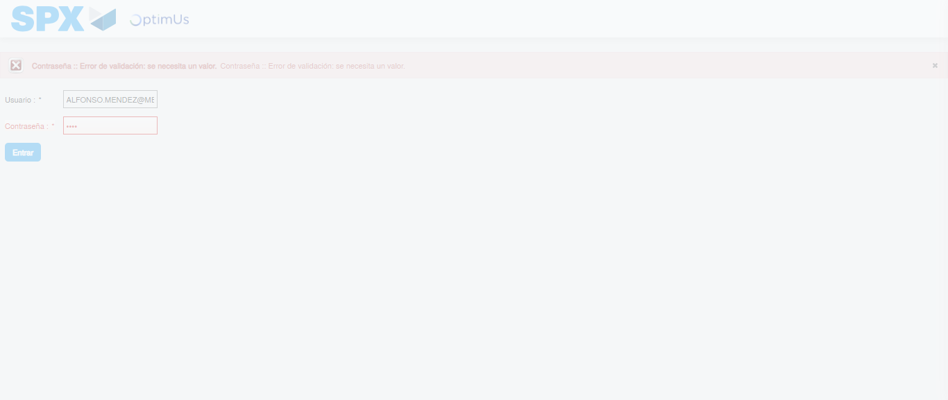Image file-name: QC_Testing-tc006_SPX_Dev5_Crear_Requisicion_Spot_Tipo_Cobro_Proyect_Urgent-1783377081475

Step 2 - Select to UEN and Access to Spot Buy Requisitions : UEN Correctly selected and Correct access
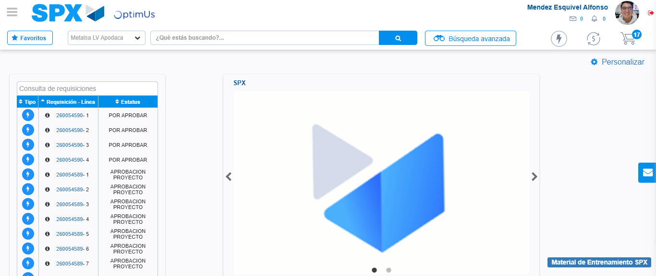Image file-name: QC_Testing-tc006_SPX_Dev5_Crear_Requisicion_Spot_Tipo_Cobro_Proyect_Urgent-1783377107111

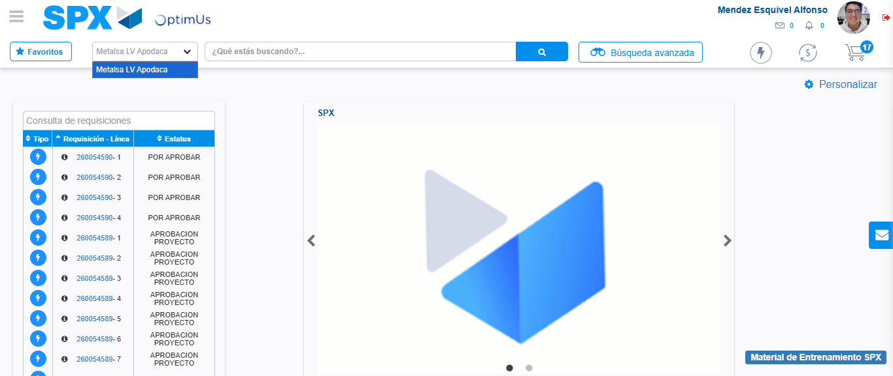Image file-name: QC_Testing-tc006_SPX_Dev5_Crear_Requisicion_Spot_Tipo_Cobro_Proyect_Urgent-1783377109605

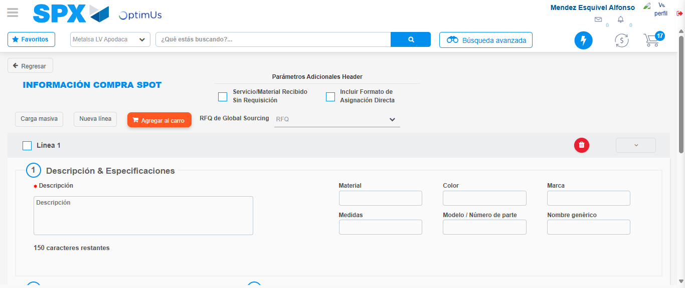Image file-name: QC_Testing-tc006_SPX_Dev5_Crear_Requisicion_Spot_Tipo_Cobro_Proyect_Urgent-1783377128566

Step 3 - Data Capture Spot Buy Requisition: Data captured correctly
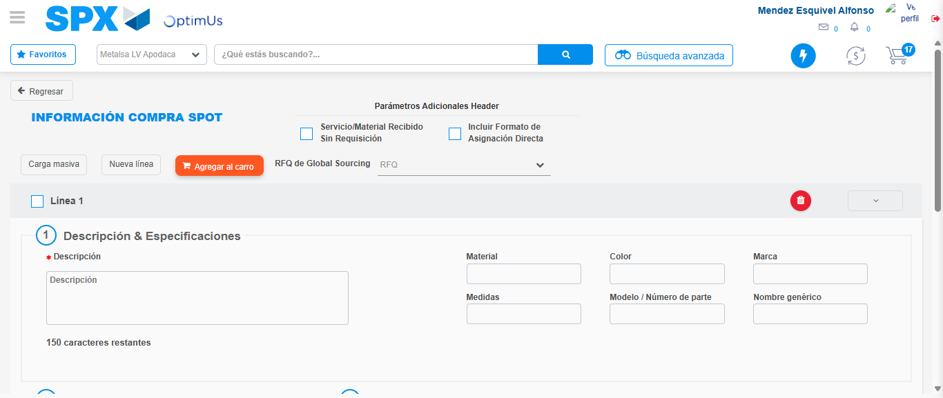Image file-name: QC_Testing-tc006_SPX_Dev5_Crear_Requisicion_Spot_Tipo_Cobro_Proyect_Urgent-1783377128864

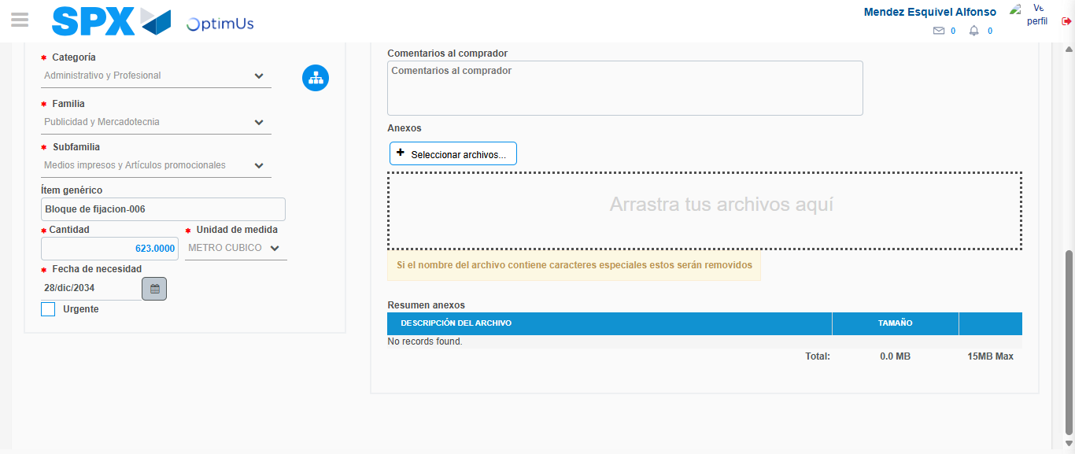Image file-name: QC_Testing-tc006_SPX_Dev5_Crear_Requisicion_Spot_Tipo_Cobro_Proyect_Urgent-1783377139053

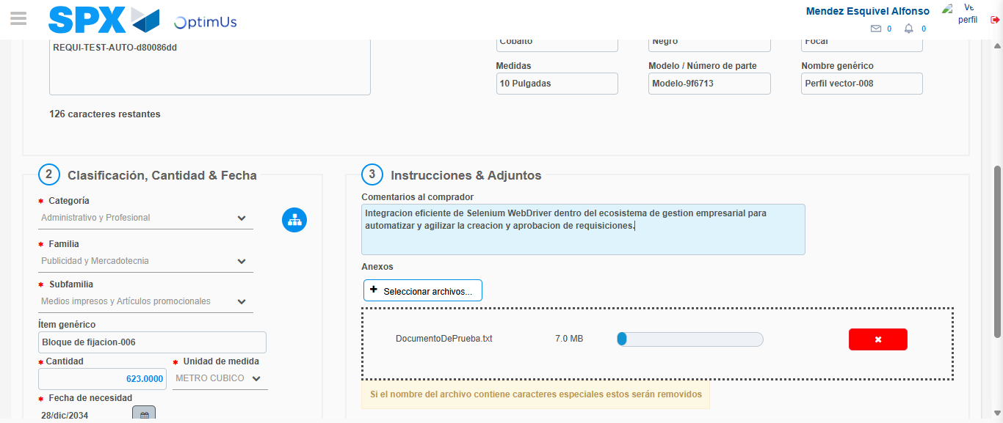Image file-name: QC_Testing-tc006_SPX_Dev5_Crear_Requisicion_Spot_Tipo_Cobro_Proyect_Urgent-1783377139799

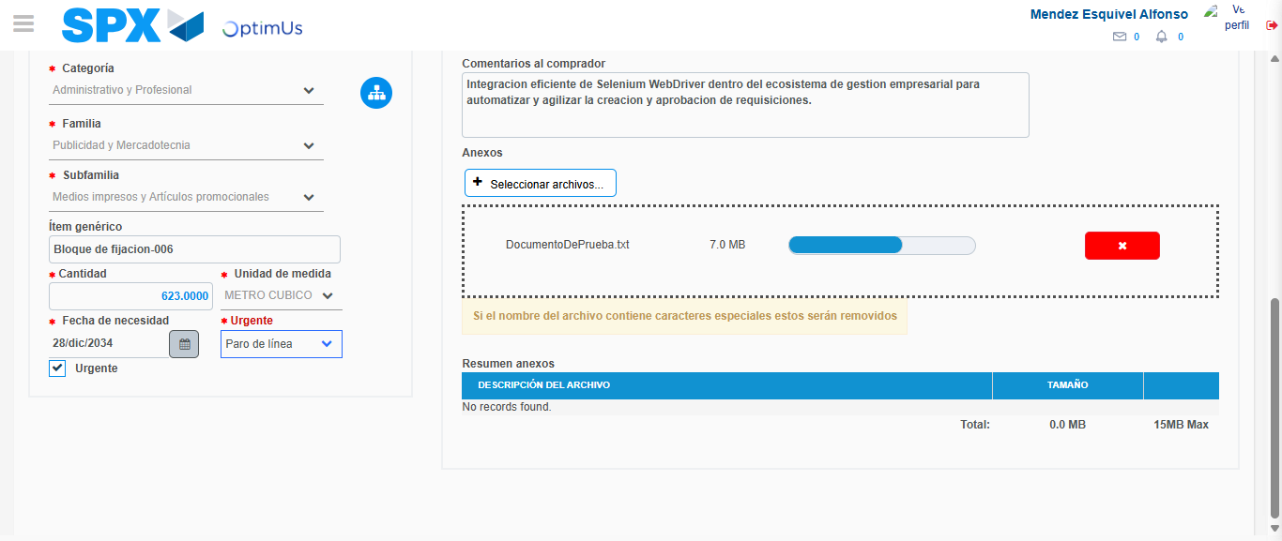Image file-name: QC_Testing-tc006_SPX_Dev5_Crear_Requisicion_Spot_Tipo_Cobro_Proyect_Urgent-1783377143409

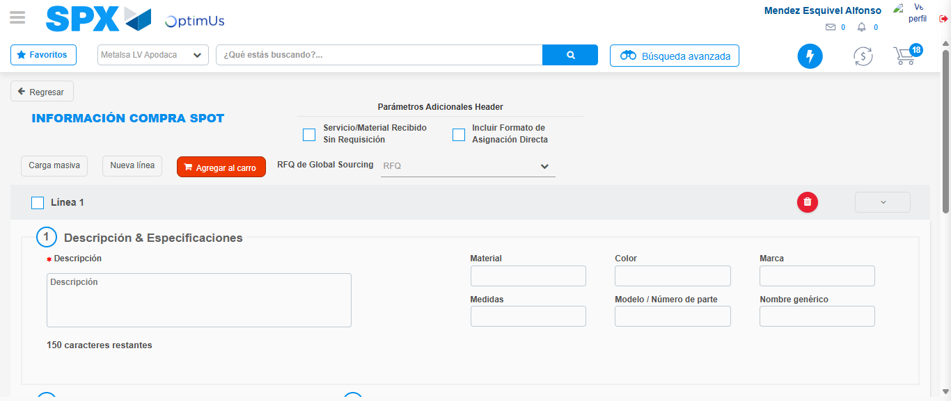Image file-name: QC_Testing-tc006_SPX_Dev5_Crear_Requisicion_Spot_Tipo_Cobro_Proyect_Urgent-1783377149874

Step 7 - Return to Main Page SPX : Return to Main Page SPX
Image file-name: QC_Testing-tc006_SPX_Dev5_Crear_Requisicion_Spot_Tipo_Cobro_Proyect_Urgent-1783377107111

Image file-name: QC_Testing-tc006_SPX_Dev5_Crear_Requisicion_Spot_Tipo_Cobro_Proyect_Urgent-1783377109605

Image file-name: QC_Testing-tc006_SPX_Dev5_Crear_Requisicion_Spot_Tipo_Cobro_Proyect_Urgent-1783377128566

Image file-name: QC_Testing-tc006_SPX_Dev5_Crear_Requisicion_Spot_Tipo_Cobro_Proyect_Urgent-1783377152089

Image file-name: QC_Testing-tc006_SPX_Dev5_Crear_Requisicion_Spot_Tipo_Cobro_Proyect_Urgent-1783377152261

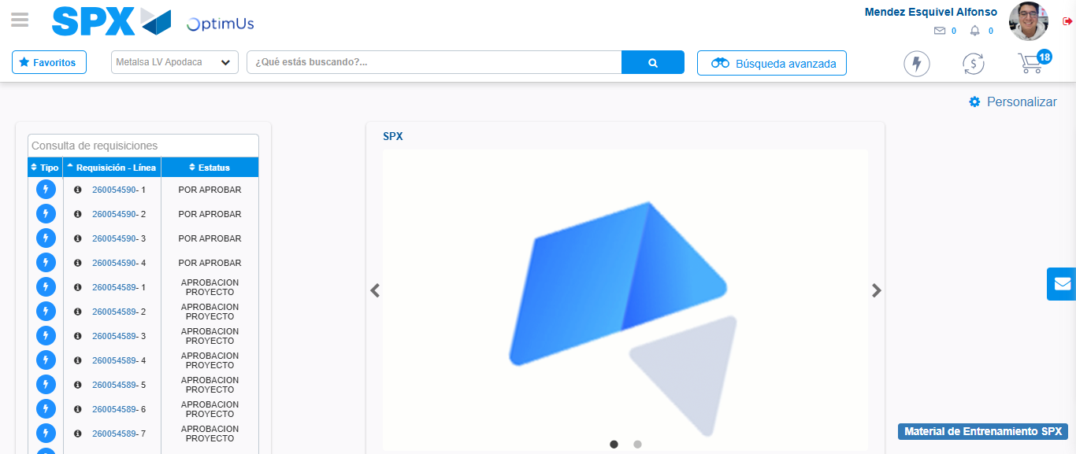Image file-name: QC_Testing-tc006_SPX_Dev5_Crear_Requisicion_Spot_Tipo_Cobro_Proyect_Urgent-1783377173237

Step 8 - Log Out : Log Out SPX
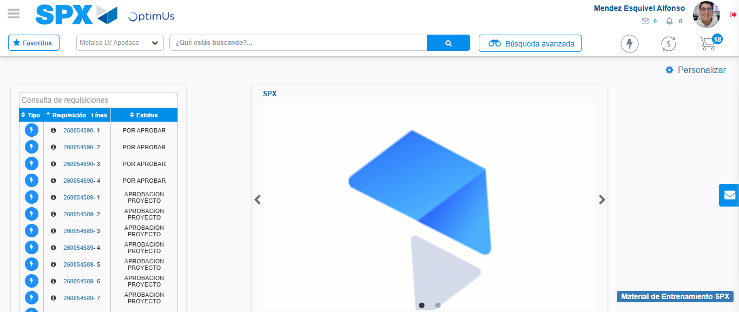Image file-name: QC_Testing-tc006_SPX_Dev5_Crear_Requisicion_Spot_Tipo_Cobro_Proyect_Urgent-1783377173481

